The Salvation Army of Alamance County Boys & Girls Club Presents

FALL
FESTIVAL
October 26, 2021 | 4:00 PM - 6:00 PM

Bounce houses Games
Hot dogs, smores, candy and MANY MORE!

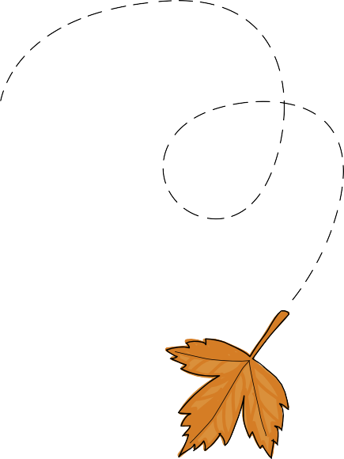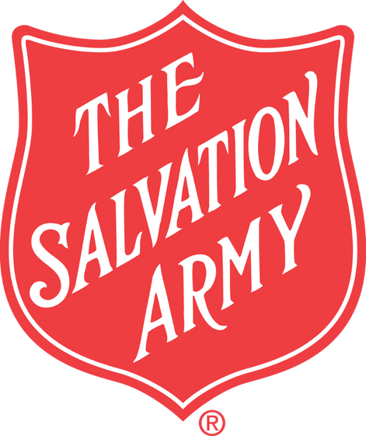FREE
ADMISSION!
336.227.5529
@TheSalvationArmyOfAlamanceCounty

